**Relict populations of a deciduous oak show high resilience to drought despite land-use legacies**

Pérez-Luque A.J., …

…

Abstract

…

- Trees showed resilience to drought events, despite the ‘a priori’ vulnerability that they can express as a result of the impact of climate change on relict stands resulting from intensive land-use in history.

- Oak resilience to drought followed a dryness gradient: Northern populations, which thrive under a drier climate, were less resilient to drought both in primary and secondary growth than Southern populations where lower altitudes were also less resilient than those at high-altitudes.

- Oak resilience was inversely related to drought intensity: trees were less resilient to the 2005 drought ¿??which was the most intense of the two studied????

…

Introduction

Sugiero la siguiente estructura:

* El estudio del crecimiento y funcionamiento de bosques en su límite de distribución es interesante porque aporta información potencialmente utilizable para su manejo en un context de cambio global. Además esta información puede ser útil para otras zonas menos marginales en el future.
* Si además estos bosques se encuentran en una zona de montaña utilizada secularmente por asentamientos humanos, el valor del estudio es mayor ya que incorpora Fuertes gradients altitudinales y un legado de usos del suelo muy importante. Concepto de laboratorio de cambio global.
* Este trabajo se desarrolla en un ecosistema que cumple las condiciones anteriores.
* Nuestro objetivo general es: estudiar el impacto de las sequías en un bosque mediterráneo usando para ello dos escalas espaciales (mountain range y micrositio), dos escalas temporales (20 años con MODIS, siglos con dendro) y varios indicadores de funcionamiento y estructura del bosque. (esto está basado en los objetivos que hay más abajo)
* En este sentido, la hipótesis de partida podría ser: la respuesta de los robledales frente a la sequía se expresa de diferente manera en las distintas escalas espaciales y temporales analizadas.

Habla de global change, de relict populations por clima y land-use. Luego introduces muy bien la zona en M-M así que en la introducción puedes meter el tema más generico para que no parezca local lo que hacs.

…

Relict populations driven by historical land-use at their climatic (either altitudinal or latitudinal) rear-edge can be particularly vulnerable to climate change. In this study we combined remote sensing information and dendroecological methods to evaluate the drought impacts in both canopy greenness (as a proxy to primary growth) and radial growth of *Q. pyrenaica* forests in Sierra Nevada. Specifically, the aims of this work were: (1) To quantify how two recent extreme drought events influenced primary and secondary growth of *Q. pyreancia* forests in their rear edge; (2) to analyze the resilience of these forests to successive extreme drought events, both in recent times and in the long-term using time-series of radial growth; (3) and to explore differences in the resilience metrics between populations located in contrasting ecological conditions within the rear edge of the distribution of this species. In addition, within the region of study we were interested to assess whether the effect of aspect and microclimatic conditions expressed in northern and southern populations of Pyrenean oak forests differ in their resistance, resilience and recovery to extreme drought events.

# Materials and methods

## Species and study site

Pyrenean oak (*Quercus pyrenaica* Willd.) forests extend through south-western France and the Iberian Peninsula reaching its southern limit in northern Morocco (Franco 1990). In the Iberian Peninsula these forests live on siliceous soils, or soils poor in basic ions (Vilches de la Serna 2014) under meso-supramediterranean and mesotemperate areas and subhumid, humid and hyperhumid ombroclimate (Rivas-Martínez et al. 2002). *Q. pyrenaica* requires over 650 mm of annual precipitation and a summer minimal precipitation between 100 and 200 mm (Martínez-Parras and Molero-Mesa 1982, García and Jiménez 2009), with summer rainfall being a key factor in the distribution of the species (Gavilan et al. 2007, Río et al. 2007).

This species reaches its southernmost European limit in Sierra Nevada, a high-mountain range located in southern Spain (37°N, 3°W) with elevations of between 860 m and 3482 m *a.s.l.*. The climate is Mediterranean, characterized by cold winters and hot summers, with pronounced summer drought (July-August). There are eight oak patches (2400 Has) identified (Figure 1) in this mountain range, ranging between 1100 and 2000 m *a.s.l.* and often associated to major river valleys. Sierra Nevada is considered a glacial refugia for deciduous *Quercus* species (Brewer et al. 2002, Olalde et al. 2002, Rodríguez-Sánchez et al. 2010) and these populations are considered as a rear edge of the habitat distribution, which is important in determining habitat responses to expected climate change (Hampe and Petit 2005).

The populations of Pyrenean oak forests at Sierra Nevada are considered relict forests (Melendo and Valle 2000, Vivero et al. 2000), undergoing intensive anthropic use in history (Camacho-Olmedo et al. 2002, Valbuena-Carabaña et al. 2010, Valbuena-Carabaña and Gil 2017). In fact, the conservation status of this species for southern Spain is “Vulnerable” (Vivero et al. 2000). The relict presence of this species in Sierra Nevada is related both to its genetic resilience and high intraspecific genetic diversity (Valbuena-Carabaña et al. 2010). However, they are also expected to suffer the impact of climate change, due to their higher hydric requirements compared to other more drought-tolerant Mediterranean evergreen oak and pine species. Thus, simulations of the climate change effects on this habitat forecast a reduction in suitable habitats for Sierra Nevada (Benito et al. 2011).

## Drought episodes

The years 2005 and 2012 were chosen as drought years for this study because they have been documented as two of the worst drought years in the last decades for the southern Iberian Peninsula (García-Herrera et al. 2007, Trigo et al. 2013, Gouveia et al. 2015) and they were charecterized as extreme drogught (i.e. -2 SD???) in our climatic data (Figure S1). Aunque sabemos que existen otros años de sequía extrema (e.g. 1995, 1981) (Vicente-Serrano et al. 2014), no se han elegido por una limitación metodológica, esto es, nuestro objetivo es analizar el efecto de la sequía y la resiliencia a los eventos de sequía utilizando información de satélite y de dendrocronología, y la información de satélite utilizada (ver mas adelante) solamente está disponible desde el año 2000 en adelante. We compare only these previous drought years in radial growth-time series, to place older drought events with those in 2005 and 2012. Caracterizar aquí o en resultados la precipitación y ETP si tienes t de 2005 y 2012, así respect a las medias que te salen (que no sé si las pones en algún sitio.)

## Greenness data

As a proxy to primary growth, to characterize the vegetation greenness of *Q. pyrenaica* we used the *Enhanced Vegetation Index* (EVI) derived from MOD13Q1 product obtained by the *Moderate Resolution Imaging Spectroradiometer* (MODIS) sensor (Didan 2015). EVI and NDVI (*Normalized Difference Vegetation Index*) are the most common greenness vegetation indices. We used EVI instead of NDVI because EVI is more sensitive to changes in high-biomass areas (a serious shortcoming of NDVI); EVI reduces the influence of atmospheric conditions on vegetation index values, and EVI corrects for canopy background signals (Huete et al. 2002, Cabello et al. 2012, Krapivin et al. 2015).

MODIS EVI Data from Collection 6 were obtanied using Google Earth Engine platform for the period 2000 - 2016. EVI data consists of 16-day maximun value composite images (23 per year) of the EVI value with a spatial resolution of 250 m x 250 m. We selected the pixels covering the distribution of *Q. pyrenaica* forests in Sierra Nevada (*n* = 928 pixels). A data filtering was applied to select EVI valid values. The filtering was done using quality flags and VI Usefulness Indices accompanying the EVI data. We filter out those values affected by high content of aerosols, clouds, snow and shadows, following the filtering recommendations of EVI data for mountain regions (Reyes-Díez et al. 2015).

After the filter out process, we built the annual EVI profile for each pixel and then computed the EVI’s annual mean values and the EVI anomaly for each pixel for the period 2000 - 2016. EVI mean was chosen since it is highly stable under the use of any filter (Reyes-Díez et al. 2015) and because it showed high significant correlations with annual (r = 0.81) and seasonal EVI values ( $r_{spring}$ = 0.76 and $r_{summer}$ = 0.88). We explored the temporal trends of EVI at a pixel scale. We computed the nonparametric Mann–Kendall test (Kendall, 1975; Mann, 1945), using the trend package in R (Pohlert 2017). We set 0.05 the alpha level for the test.

To explore the effect of drought events on greenness we calculated the EVI standardized anomaly ($EVI sa$) pixel-by-pixel, since it minimizes biases in the evaluation of anomalies, providing more information about the magnitude of the anomalies (Samanta et al. 2012, Gao et al. 2016). For each pixel we annually averaged all the EVI valid values, and then the standardized anomaly was computed as:

$$EVI_{sa,i}=\frac{EVI_{mean,i}-EVI_{mean,ref}}{σ_{ref}}$$

where $EVI_{sa,i}$ is the EVI standardized anomaly for year $i$; $EVI_{mean,i}$ the annual mean value of EVI for year $i$; $EVI_{mean,ref}$ the average of the annual EVI values for the period of reference 2000-2016 (all except $i$ year), and $σ_{ref}$ the standard deviation for the reference period. Each pixel was categorized according the EVI standardized anomalies as “greening” (EVI standardized anomalies greater than + 1), “browning” (EVI standardized anomalies less than - 1) or “no changes” (EVI standardized anomalies between − 1 and + 1) (Samanta et al. 2010, 2012).

## Field sampling and dendrochronological methods

### Tree sampling

Tree sampling was carried during autumn of 2016. Trees were sampled at two locations in contrasting slopes of Sierra Nevada: San Juan (SJ; northern aspect) and Cáñar (CA; southern aspect) (Figure 1; Table 1). Decir algo aquí sobre difrencias microclimáticas entre el norte (más seco, más continental?) y el sur (más húmedo pero más oceánico/cálido?). For the southern site two elevations were sampled: CA-Low and CA-High. All the sites were oak monospecific and representatives of two of the three population clusters identified for the species in this mountain range (Pérez-Luque et al. 2015a). In each site between 15 and 20 dominant trees were randomly selected. Two cores of 5 mm of diameter were taken from each tree at breast heigth (1.3 m) using an increment borer. Diameter at breast height (DBH) and total height were measured using a girth tape and a Vertex IV ultrasonic hypsometer (Haglöf, Sweden) respectively. We assessed stand competition of target trees by recording distance, azimuth, dbh, species and total height of all neighboring living trees with dbh > 7.5 cm in a circular plot of 10 m radius. We computed two distance independent indices: *density* in $trees⋅ha^{-1}$, and *basal area* (BA) in $m^{2}⋅ha^{-1}$; and one distance dependent indices: size ratio proportional to distance (*srd*) as $srd=\sum_{i=1}^{n}{(}dbh_{j}/dbh_{i})⋅\left[1/(dist_{ij}+1)\right]$. We used non-parametric Kruskal-Wallis rank sum tests (Sokal and Rohlf 1995) to analyse differences between sites for height, DBH and competence indices. When significant differences were observed, we run multiple comparisons using the Dunn’s-test (Dunn 1964) with Bonferroni adjustment to correct significance values. These analysis were performed using the PMCMR package in R (Pohlert 2014).

### Dendroecological analyses

Tree cores were air dried, glued onto wooden mounts and sanded. Annual radial growth (ring width, RW) was measured with a LINTAB measuring device (Rinntech, Heidelberg, Germany) coupled to a stereomicroscope, with an accuracy of 0.001 mm. Individual ring series were first visually and statistically cross-dated with TSAP software (Rinntech, Heidelberg, Germany), using the statistics Gleichläufigkeit (GLK), t-value and the crossdating index (CDI). Cross-dating validation was finally done using COFECHA (Holmes 1983).

The growth trends were analyzed at different time scales. To study the response of growth to the inter-annual variability of climate (short-term response) we used pre-whitened residual chronologies (RWI) calculated from ratios between raw growth measurements and individual cubic splines with a 50 % frequency cutoff at 30 years (Fritts 1976). Tree-ring width series were standardized and detrended using the dplR (Bunn 2008, 2010) package. Residual site chronologies were obtained computing the biweight robust mean of all prewhitened growth indices for the trees of the same site (Cook and Kairukstis 1990). The statistical quality of each chronology was checked via the expressed population signal. A threshold value of EPS > 0.85 was used to determine the cutoff year of the time span that could be considered reliable (Wigley et al. 1984).

The long-term growth response was analyzed using basal area increment (hereafter BAI, $cm^{2}⋅year^{-1}$). Theoretically, BAI represents a more accurate indicator of growth than ring-width, since it removes variation in growth attributable to increasing stem circumference after 30-40 years of juvenile increasing growth (Biondi and Qeadan 2008). We used measured dbh and raw ring-widths to compute BAI by subtracting twice the annual ring width from the annual diameter, starting from the measured diameter outside the bark (Piovesa et al. 2008). We used the following equation:

$$BAI=π(r_{t}^{2}-r_{t-1}^{2})$$

where $r$ is the radius of the tree and $t$ is the year of tree-ring formation. We calculated a mean BAI series for each individual tree. Mean site BAI chronologies were obtained by averaging individual tree BAI time series.

Both RWI and BAI chronologies were compared to different climatic indices to analyse the low and the high-frequency response to climate of trees. Statistical descriptive parameters (Fritts 1976) including the mean, standard deviation, first-order autocorrelation of raw series, the mean sensitivity (a measure of the year-to-year variability) and the mean correlation between individual series of residual ring-width indices, were also calculated for each site chronology (Fritts 1976).

### Climate and growth

Climate data were obtained from the European Daily High-Resolution Observational Gridded Dataset (E-OBS v16) (Haylock et al. 2008). Monthly precipitation and minimum and maximum temperatures were obtained at a 0.25 x 0.25 º resolution for the 1950-2016 period. We selected grid cells covering each sampled sites. Data were downloaded and preprocessed using the climate4R bundle (<http://www.meteo.unican.es/en/climate4R>) (Cofiño et al. 2018, Frías et al. 2018). We also used the Standardized Precipitation-Evapotranspiration Index (SPEI), a multiscalar drought index that incorporates both precipitation and temperature (Vicente-Serrano et al. 2010, Beguería et al. 2014). SPEI values for the period 1961-2014 were obtained with a spatial resolution of 1.1 km from the Drought indices dataset for Spain database (<http://monitordesequia.csic.es/>), a high resolution database of drought indices for Spain (Vicente-Serrano et al. 2017). We selected a temporal scale for the SPEI of 6 months.

Relationships between residual site chronologies and climatic variables were assessed using bootstrapped Pearson’s correlations estimated using the treeclim package (Zang and Biondi 2015). The bootstrapped confidence intervals were used to estimate significance (p < 0.05) of the correlation coefficients.

### Disturbance analyses

Disturbance chronologies were built using tree-ring width to identify abrupt and sustained increases (release events from competition) or decreases (supressions) in radial growth (Nowacki and Abrams 1997) as indirect estimates of possible disturbance events (e.g. logging) in the past. By using a temporal window of reasonable length this method is intended to filter out the response to short-term changes in temperature and precipitation and minimizes the long-term growth trends (Nowacki and Abrams 1997, Fraver and White 2005).

Growth changes (GC) were calculated for the individual tree-ring series using a 10-year running window as either positive (PGC) or negative (NGC) growth changes:

$$\%GC=\left[\frac{\left(M1-M2\right)}{M2}\right]×100$$

where $M1$ is preceding 10-year median and $M2$ is subsequent 10-year median. We used medians since they are more robust estimator of central tendency than means (Rubino and McCarthy 2004, Camarero et al. 2011). Site disturbance chronologies were constructed by averaging the individual disturbances series annually. To separate growth peaks produced by disturbance events and expressing stand-wise disturbances from those by climate, we considered a threshold of 50 % (DUDA) of GC and more than 50% of the individual trees displaying the same growth changes was considered a stand-wise disturbance.

## Resilience

To evaluate the effects of drougth events on greeennes and tree growth (BAI) we used three resilience indices proposed by Lloret et al. (2011): resilience (*Rs*), resistance (*Rt*), and recovery (*Rc*). The resistance index (*Rt*) quantifies the severity of the impact of the disturbance in the year it occurred. It is estimated as the ratio between the performance during and before the disturbance (drought) event:

Resistance (*Rt*) = Drought / Predrought

The Recovery index (*Rc*) is the ability to recover from disturbance relative to its severity, and it is estimated as the ratio between performance after and during disturbance:

Recovery (*Rc*) = Postdrought / Drought

The Resilience index (*Rs*) is the capacity to reach pre-disturbance performance levels, and it is estimated as the ratio between the performance after and before disturbance:

Resilience (*Rs*) = Postdrought / Predrought

We computed the values of these indices for tree growth (BAI) and greenness during each drought event. We considered 2005 and 2012 as single drought events. The predrought and postdrought values of each target variable (*i.e.*: BAI or EVI) were computed as the mean value during a period of three years before and after the drougth event respectively. A period of three years was chosen because we found similar results comparing periods of two, three and four years (Figure S4) and this length was used in other studies (Gazol et al. 2017). In addition we calculated the same indices for BAI data for X drought events (2SD of hydrological year precipitation) since

## Statistical analysis

We used robust two-way ANOVAs to test for differences between drought events (2005 and 2012) and the two studied oak populations (northern and southern slopes/aspect?) for each of the three resilience indices studied. These test were used because original and log-transformed data did not followed the assumptions of normality and homogeneity of variance (Wilcox 2012). Robust measures of central tendency (M-estimator based on Huber’s Psi) were used since they were close to the mean value in all cases (Wilcox 2012). When running the robust ANOVA test, data were boostrapped 3000 times and trimmed automatically to control the potential influence of outliers (Field et al. 2012, Wilcox 2012). Post-hoc differences were assessed pairwise using a similar boostrap test. All the robust ANOVA and post-hoc tests were carried out using the WRS2 (Mair et al. 2017) and rcompanion (Mangiafico 2017) R packages. The level of significance was set to 0.05 and adjusted for multiple comparisons. All analyses were carried out in R software (R Core Team 2017) using several packages (see Supplementary S?)

# Results

## Time trends in Vegetation Greenness

The analysis of greenness time trends showed that 78.9 % of the pixels of *Quercus pyrenaica* forests experienced an EVI positive trend for the 2000-2016 period, of which 31.67 % were significant. The strongest trends were observed in southwestern populations (Figure S2), which are coincident with the Cáñar site???. Vegetation greenness of *Q. pyrenaica* forests were lower during both the 2005 and 2012 years than the greenness observed for the reference period (Figure 2a). The lowest values for EVI standardized anomalies were recorded in 2005 being singnificantly lower (-2.285 ± 0.029) than those in 2012 (-0.418 ± 0.029) (LSMEANS, t.ratio = -45.358; p_value < 0.0001), particularly for northern populations (Figure 2b). Reduction in annual EVI mean was considerably higher in northern populations than in southern ones during the 2005 drought (Figure 2b).

According to the standardized anomalies, *Q. pyrenaica* forests suffered a ‘browning episode’ during 2005 drought event (99.36 % and 79.37 % of the pixels for northern and southern populations respectively), yet no changes in greenness were observed in response to the 2012 drought (Figure S3).

## Greenness resilience to drougth events

*Q. pyrenaica* forest showed significantly lower resistance (Rt) to the 2005 drought event than to that in 2012 (Table 3; Figure 3a). The 2005 drought reduced the greenness of oaks to a 85.8 % respect the reference period? while the 2012 reduced it 94.3 % (Table S1). Southern populations showed significantly higher values of resistance to drought than northern ones (Table 3), except for 2012 where non-significant differences were recorded (Table S1. Figures 3a, 4a).

The oak forests recovered (Rc) their greenness significantly more rapidly after the 2005 drought than after 2012 (Tables 3, S1). In the 3-year period after the 2005 drought, greeness achieved was 112 % (Rc = 1.12) and after 2012 was 105.7 % (Rc = 1.057) (Table S1). A similar recovery after the 2005 and 2012 drought event was observed for southern populations (p = 0.2453; Figure 4a), whilst the northern populations showed a significantly greater recovery after the 2005 drought than after the 2012 drought (Figure 4a).

Resilience (Rs) was significantly higher for the 2012 drought event than for 2005 (Tables 3, S1), although both values were close to 1 indicating that greenness level was rather similar after each disturbance event (Table S1). The southern populations showed higher resilience values than the northern ones, although they were not significantly different for 2005 drought (p = 0.036; Figures 3a, 4a).

## Radial Growth trends and climate

Likely as a consequence of their different management origin (i.e. land-use legacy), the trees of the southern population were older than northern ones, particularly for the high elevation site (Ca-High) which had bigger and taller trees than the other sites (Tables 1, 2). The competition index was similar among sites but plot basal area was greatest in CA_high (Table 1). Yet the basal area increment (BAI) growth in the highest plot in altitude (Ca-High) was the greatest (Figure 5). Trees from this location showed in addition a positive growth trend since the late 1970s. This positive trend was not found in any of the other two locations and the two altitudes sampled in the Southern populations showed differences in growth, being more similar Ca_Low with growth in the Northern population (SJ) than with Ca_High.

Los tres sitios mostraron una reducción en los valores de BAI durante las sequías de xxxxx, 1995 y 2005, y menos evidente para el año 2012 (Figure 5). La población del norte (SJ) mostró una gran liberación en torno a 1945 fruto quizá de cortas asociadas a la actividad minera de la zona. Asimismo, esta población mostró un marcado descenso en BAI durante el periodo 1986 - 1999.

1995 was the lowest pointer year (i.e. the lowest growth) since 1950 in all chronologies. Los tres sitios mostraron valores de ring width indices bajos para el año 1995 (Figure 6). El sitio SJ mostró valores muy bajos de ring width indices en 1995, 2005, y 2012. Sin embargo esto no ocurrió igual en los sitios del sur (caL y CaH) donde si encontramos valores bajos de RWI para 1995, pero no para 2005 y 2012.

Sorprende que en los sitios del sur (caH y caL), en los últimos años ha habido crecimientos muy grandes. Por ejemplo, en 2010 se observó uno de los mayores valores de RWI de toda la cronología tanto en caH como en caL. Algo similar ocurrió en sj para los años 2003 y 2013.

## Resilience of radial tree-growth to drougth events

Although no significant differences were observed in the resistance (Rt) of oak radial growth between the two drought events (Table 3), the 2005 drought reduced growth more than that of 2012 (Rt = 0.721 and 0.819 respectively) (Table S2). Similar to results for greenness, the northern site, which is under a drier climate, showed resistance values lower than those of the southern site, especially for the 2005 drought event where the growth was reduced to 44.5 % respect to that of the preceding period (Figures 3b, 4b).

Oak forests recovered (Rc) their growth more rapidly after 2012 (less intense drought?) than after 2005 staying at levels of Rc < 1 (Table S2). Northern populations showed signigicantly higher values of recovery than southern ones (Tables 3 and S2), which even not reach recovery values of Rc = 1 (Figure 3b, 4b).

Significantly higher values of resilience of growth were observerd for the 2012 drought event than for the 2005 one (Table S2; Figure 4b). We found no differences of resilience values for growth between northern and southern populations (Table 3). For 2005 drought event the resilience of northern population was lower than that of southern ones, but opposite pattern was found for the 2012 drought event, with northern population showing values greater than unity (Figure 3b). Es intersante que los valores de resiliencia para el tree-growth no alcanzaron el valor 1, excepto para 2005 en la población de SJ (Rs = 1.031)

## Climate and tree-growth

Tree-growth exhibited a significant greater response to water availability than to temperatures, as it can be expected for a Mediterranean site and a species located closer to its xeric/dry distribution limit (rear-edge). Cumulative precipitation of the hydrological year was the climatic variable with the highest relationship with growth and influenced similarly and positively the tree-growth for both northern and southern populations (Figure 7a). Precipitation of previous december was also positively correlated with tree growth in the northern population and in the highest location of the southern population. Hydrological, Spring and Summer SPEI showed a strong positive correlation with tree-growth (Figure 7b), specially for the northern population (r > 0.6), which can be interpreted as higher sensitivity to drought of a drier site (Gea-Izquierdo and Cañellas 2014). Relationships with temperatures were lower than those with moisture variables. Yet there were differences between northern and southern populations: spring maximum temperature was the most significant limitation for the tree-growth of the southern population at both elevations while maximum temperatures of the previous August were the only negative significant for the northern one (Figures 7c and 7d). Remarkably minimum and maximum temperatures of current September positively influenced the tree-growth only in the northern population. No positive relationship with temperature was found for southern trees.

## Disturbances

The analysis of growth changes revealed differences between sites (Figures 8 and 9). En el sitio del norte osbervamos dos eventos de liberación importantes (GC > 50 %), que ocurren en mas de la mitad de los árboles muestreados (Figures 8 and 9). El primero de ellos desde 1940 hasta 1950, mientras que el segundo entre 1994 y 2001. Estos periodos se relacionan bien con eventos antrópicos: mineria (el primero de ellos) y actividades forestales el segundo (esta frase de la minería y demás la dejamos para la discusión??). Estos periodos se alternan con periodos de supresión. En los sitios del sur (caH y caL), sin embargo se observan algunos episodios débiles de supresión, aunque estos no se observan para los últimos años, de hecho incluso se observa una débil liberación cuándo??? (Figure 8) afectando a mas de la mitad de los árboles muestreados (Figure 9).

# Discussion

### 1) Oaks show high resilience in response to recent drought events

…

**2) Differences in sensitivity to climate and drought of rear-edge oak populations is explained by site microenvironment**

**2) Site environment shapes differential sensitivity of rear-edge oak populations to face up climate change**

**…**

### 3) Land-use legacy effects shape distribution and sensitivity to climate change of read-edge oak populations

…

### Efectos de la sequía en el greenneess y en el crecimiento.

Hemos observado como las sequía, sobre todo la de 2005, provoca una reducción en el greenness y pero sobre todo en el crecimiento. Los datos de anomalías estandarizadas de EVI mostraron un browning para la mayoría de los robledales de Sierra Nevada durante la sequía de 2005.

La sequía de 2005 fue una de las mas severas afectando significativamente al crecimiento. Esto se ha observado también en otras especies en el sur de la P. Ibérica (p.ej. P. nigra en Andalusia (Sánchez-Salguero et al. 2013), … INCLUIR otras especies y citas).

Algunas notas sobre la sequía de 2005:

* 2004/2005 hydrological year is considered one of the worst drooughts ever recorded in the Iberian Peninsula, particularly in the central and southern sectors (García-Herrera et al. 2007).
* The southern half of Iberia received less than 45 % of the usual precipitation between October 2004 and June 2005 (García-Herrera et al. 2007).
* The hydrological year from October 2004 to September 2005 was the driest on record at several locations throughout Iberia (García-Herrera et al. 2007).
* An analysis of the long term series from meteorological stations (n=54) of Iberian Peninsula (1961-2011) reveals that major drought episodes in the Iberian Peninsula were recorded in 1981, 1995, 2000 and 2005 (Vicente-Serrano et al. 2014).

### La resiliencia de las poblaciones de roble de Sierra Nevada.

El greennness de los robledades en Sierra Nevada ha mostrado una tendencia positiva hacia mas verdor en los ultimos años, que coincide con lo que ya observamos con datos de NDVI (Pérez-Luque et al. 2015b), sobre todo para las poblaciones del sur. Esta tendencia positiva, obtenida de variables derivadas de remote sensing (EVI y NDVI), parece que también se observa en el crecimiento. Por ejemplo en las poblaciones del sur (CaHigh y CaLow) observamos en los últimos años una ligera tendencia de crecimiento.

Aún habiendo pasado varios periodos de sequía severa (sobre todo 2005, el crecimiento -BAI- en el N, se redujo hasta el 45 %), estos robledales han mostrado una alta resiliencia. Por ejemplo para las poblaciones del norte, los valores de EVI durante la sequía de 2005 descendieron hasta el 81 %, mientras que el BAI (sitio SJ) lo hizo hasta el 45 %. Sin embargo, la recuperación fue rápida, así los valores de Recovery (Rc) para el EVI tras la sequía de 2005 (en las poblaciones del norte) fue de 1.17, mientras que para el BAI el Rc fue de 1.112. En definitiva, estamos observando altos valores de resiliencia en estos robledales.

### Diferencias entre sitios

Llama la atención que en el rear-edge de la distribución de la especie, en el sitio mas meridional dentro de este rear edge, y en la parte mas alta (estas parcelas están en el treeline de la especie en SN (en torno a 1900)), es donde encontramos mayores crecimientos. Parece que los robles estuvieran mejor en esta zona. Algunas reflexiones sobre esto:

* Quizá están creciendo donde les están dejando (menor impacto antrópico en las zonas mas altas, al menos en los últimos años??)
* ¿Diferentes niveles de compentencia?. Parece que la competencia es similar en los tres sitios: no diferencias sig. para valores de Stand density ySize ratio proportional to distance (ver table 1).
* ¿Diferencias entre suelos?? En principio no. (“Taxonomic and functional diversity of a quercus pyrenaica willd. rhizospheric microbiome in the mediterranean mountains” 2017) en un trabajo sobre microbiota del suelo, explora diferencias en un gradiente altitudinal en Cáñar. Analiza 3 sitios: por encima del treline (XZF, el piornal), low altitudinal oak forest (LAF, en la zona baja del robledal) and high altitudinal oak forest (HAF). En su trabajo, LAF está mucho mas bajo, pero HAF está cerca de las parcelas caHigh. Restulados:
  + tipo de suelo: LAF es Sandy-loam, HAF es loam
  + HAF tuvo los valores mayores de disponibilidad hídrica (% available water tabla s1 en (“Taxonomic and functional diversity of a quercus pyrenaica willd. rhizospheric microbiome in the mediterranean mountains” 2017)) –> Esto es importante, creo
  + Los tres sitios eran pobres en materia orgánica, pero el HAF dobló los valores de los otros dos sitios
  + No diferencias en contenido de N, C/N ratio similares en HAF, y LAF
* ¿Menor estrés hídrico en zonas mas altas? Puede ser que tengamos menor estrés hídrico en esta zona?? Este robledal, está en la cara sur de SN, y en una ladera con bastante insolación. Algunos trabajos antiguos (de fitosociólogos) hablan de que su presencia aquí se debe a que reciben un aporte extra de humedad procedente de las brisas del mediterráneo, para suplir el mínimo de humedad que necesitan en verano. Quizá también tendríamos que incluir el papel de las acequias. La zona caHigh tiene una acequia muy cerca (y por encima) de donde muestreamos (recordad el roble mas grande, y el mas alto, esta justo en una acequia). No se si es interesante que lo comentemos.
* Otro punto de interés a introducir aquí es que frecuentemente se asume una alta vulnerabilidad a la sequía de las poblaciones situadas en su dry rear-edge (Martínez-Vilalta 2018), sin embargo algunos estudios están demostrando esto no es siempre así (ver por ejemplo (Cavin and Jump 2017, Granda et al. 2017)). Nuestros resultados creo que van en esta línea creo. Esto, como apunta (Martínez-Vilalta 2018)m tiene que ver con la que consideramos como habitat marginal de la especie (… When the focus is on marginal, rear-edge populations, proper consideration should be given to the different ways in which marginality can be defined (stressing geographical, climatic or other ecological factors).

### ¿Que factor es mas limitante para el crecimiento en el rear-edge de Q. pyrenaica?

Aquí pueder ser interesante comentar algo de el peso de las variables climáticas en el crecimiento para poblaciones situadas en el borde de distribución (pesa mas la temperatura o la disponibilidad de agua?).

Para *Q. pyrenaica* moisture availability was reported to be the most limiting factor driving radial growth in Iberian Q. pyrenaica populations (Gea-Izquierdo and Cañellas 2014) (Prec hidrológica y SPEI) (ver también Gea-Izquierdo et al. 2015 European Journal of Forest Research). Lo que hemos obtenido aqui (analizando solo el rear edge) también van en esa línea.

Podríamos complementarlo con lo que le pasa a otras especies en su borde de distribución: por ejemplo en Baza, Herrero et al. 2013, encontraron para Pinus nigra y sylvestris que la temperatura tenía mas peso que la disponibilidad de agua). O también ver algunos de los trabajos de Camarero et al 2013 para el P. nigra en su borde de distribución u otros similares (el de Sanchez-Salguero et al. 2013, 2015) …

## historia forestal de ambos sitios

Incluimos lo que conocemos de la historia forestal de los sitios?? Me explico, tenemos datos de manejo y uso antrópico de las dos zonas que proceden de varias fuentes. En resumen, mas o menos, tenemos:

* Minería: datos de minería, que afectan sobre todo a la población de SJ (los tenemos localizados temporalmente)
* Actuaciones forestales: Tenemos una bd con actuaciones forestales, y he contactado con varios de los responsables de proyectos de actuaciones forestales en ambas zonas, y tenemos con bastante detalle la información sobre actuaciones forestales (al menos espacial y temporalmente)
* Incendios, Carboneo, Ganadería, etc –> Tenemos información menos estructurada sobre estos ámbitos, procedentes de varias fuentes, que tienen una incertidumbre mayor espacial y temporalmente.

Todo esto lo comento, porque quizá podemos utilizar dicha información para la discussión, o a lo mejor mete mas ruido (¿que opináis?)

Por otro lado, sabemos que estos robledales han estado sometido a muchos ciclos de coppiccing, lo que podrían haber reducido su diversidad genética, y por tanto su resiliencia. Pero varios trabajos (Valbuena-Carabaña and Gil 2013, 2017) han encontrado que esta especie en su límite de distribución sur, muestra unos altos niveles de resiliencia (en este caso genética).

## refugio??

Los robledales de SN estén situadas en su borde rear-edge donde se supone que sufren mas estrés climático. Hemos observado un aumento en el greenness en los últimos años. Por otro lado, hemos encontrado que son poblaciones resilientes a la sequía, tanto para el crecimiento como para el greenness. Además, estos robledales tienen una alta resiliencia genética (Valbuena-Carabaña and Gil 2013, 2017). ¿Sierra Nevada (regiones de montaña) como refugio?? quizá este rear-edge esté actuando como refugio?? (esto es muy especulativo)

### Figures

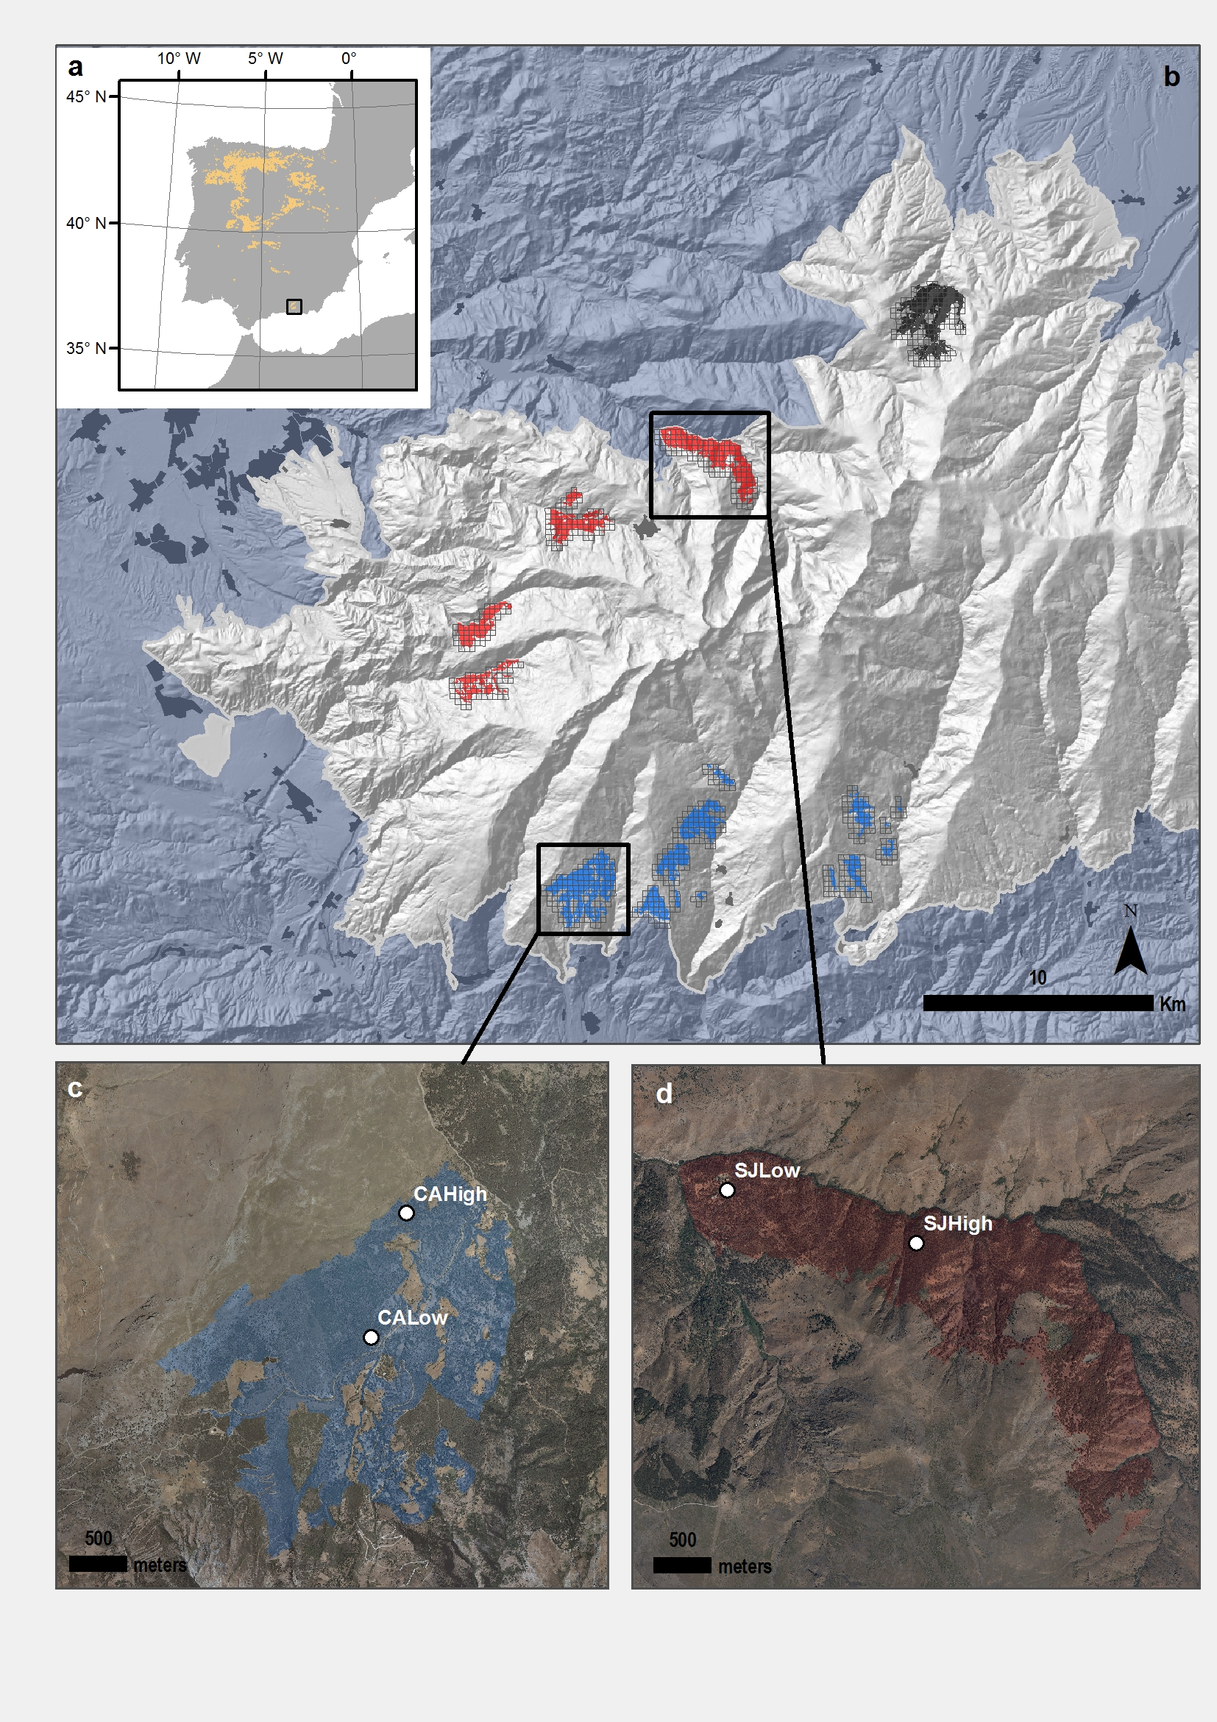

**Figure 1**. Distribution of *Quercus pyrenaica* forests in Iberian Peninsula (a) and in Sierra Nevada mountain range, where three clusters of oak populations have been identified (Pérez-Luque et al. 2015) (showed in different colour) (b). A grid of with the MODIS pixels for each population is shown (see material and methods). Detailed location of the sampling sites: northern (San Juan, SJ) (c) and southern ones (Cáñar: CALow and CAHigh)(d). Colour Orthophotography of 2009 from Regional Ministry of the Environment, Regional Government of Andalusia.

### Figure 2

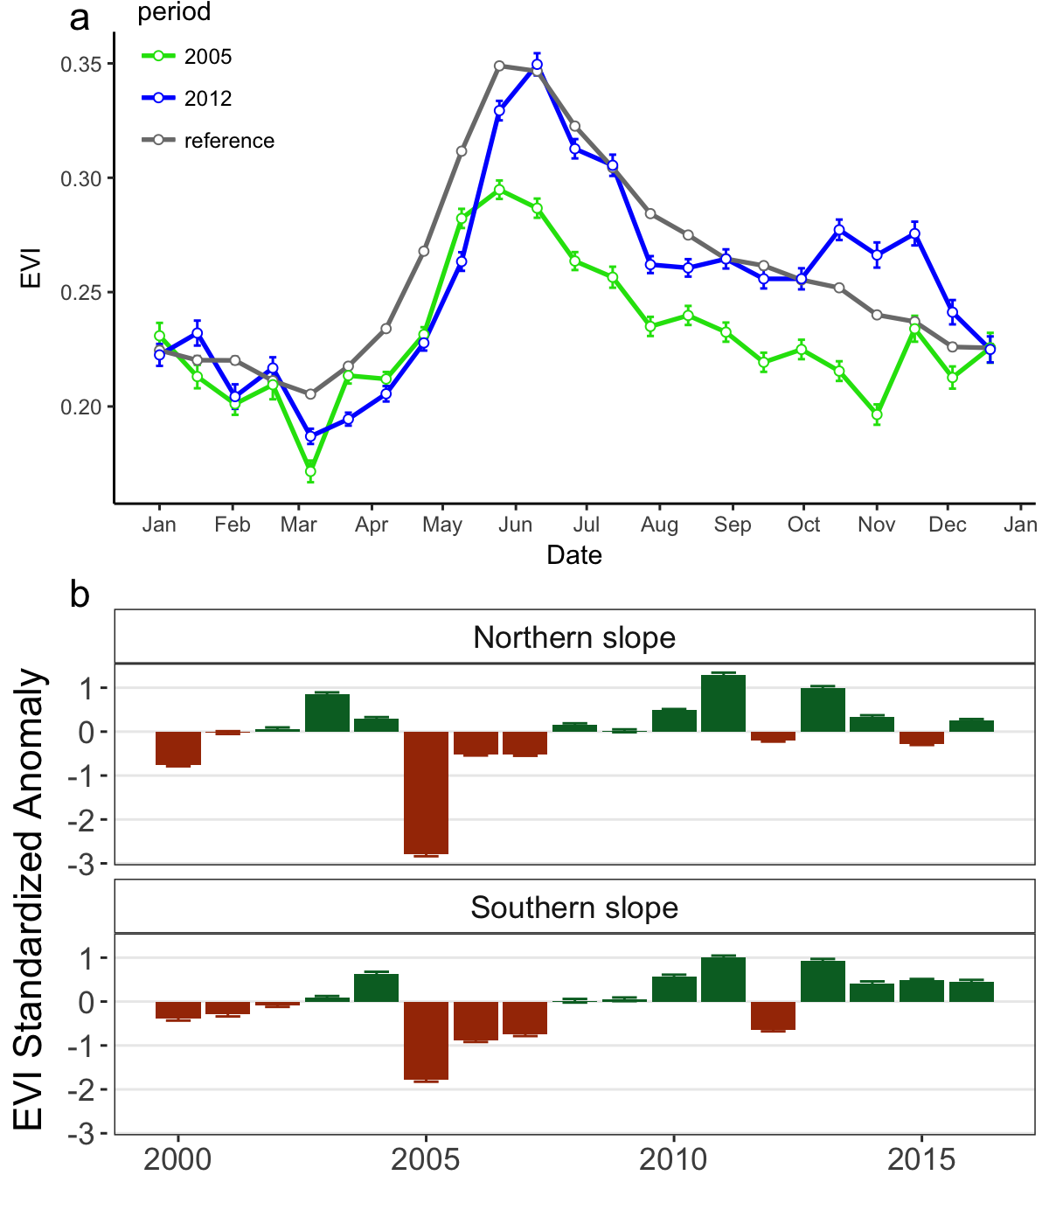

**Figure 2.** Comparison of EVI profile for the reference period (*gray*) and during the 2005 (*green*) and 2012 (*blue*) drought events (a). EVI standardized anomaly ($EVI sa$) during the period 2000-2016 for northern and southern populations (b). Error bars show standard error.

### Figure 3

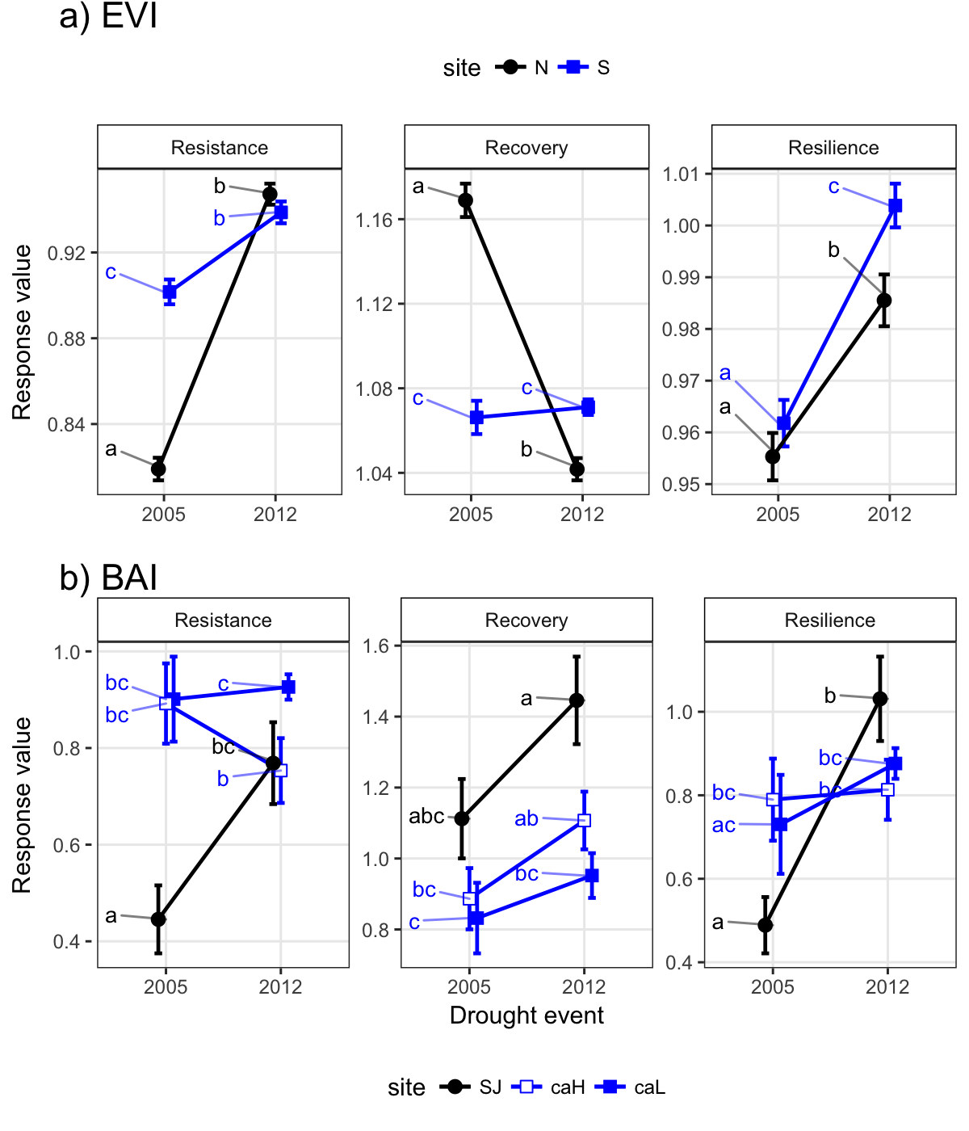

**Figure 3.** Response of northern (*black*) and southern (*blue*) populations of *Q. pyrenaica* forests to drought in terms of resistance, recovery and resilience of greenness (EVI; a) and tree radial growth (BAI; b) for the years 2005 and 2012. Different letters above bars indicate significant post hoc differences between groups (see material and methods).

### Figure 4

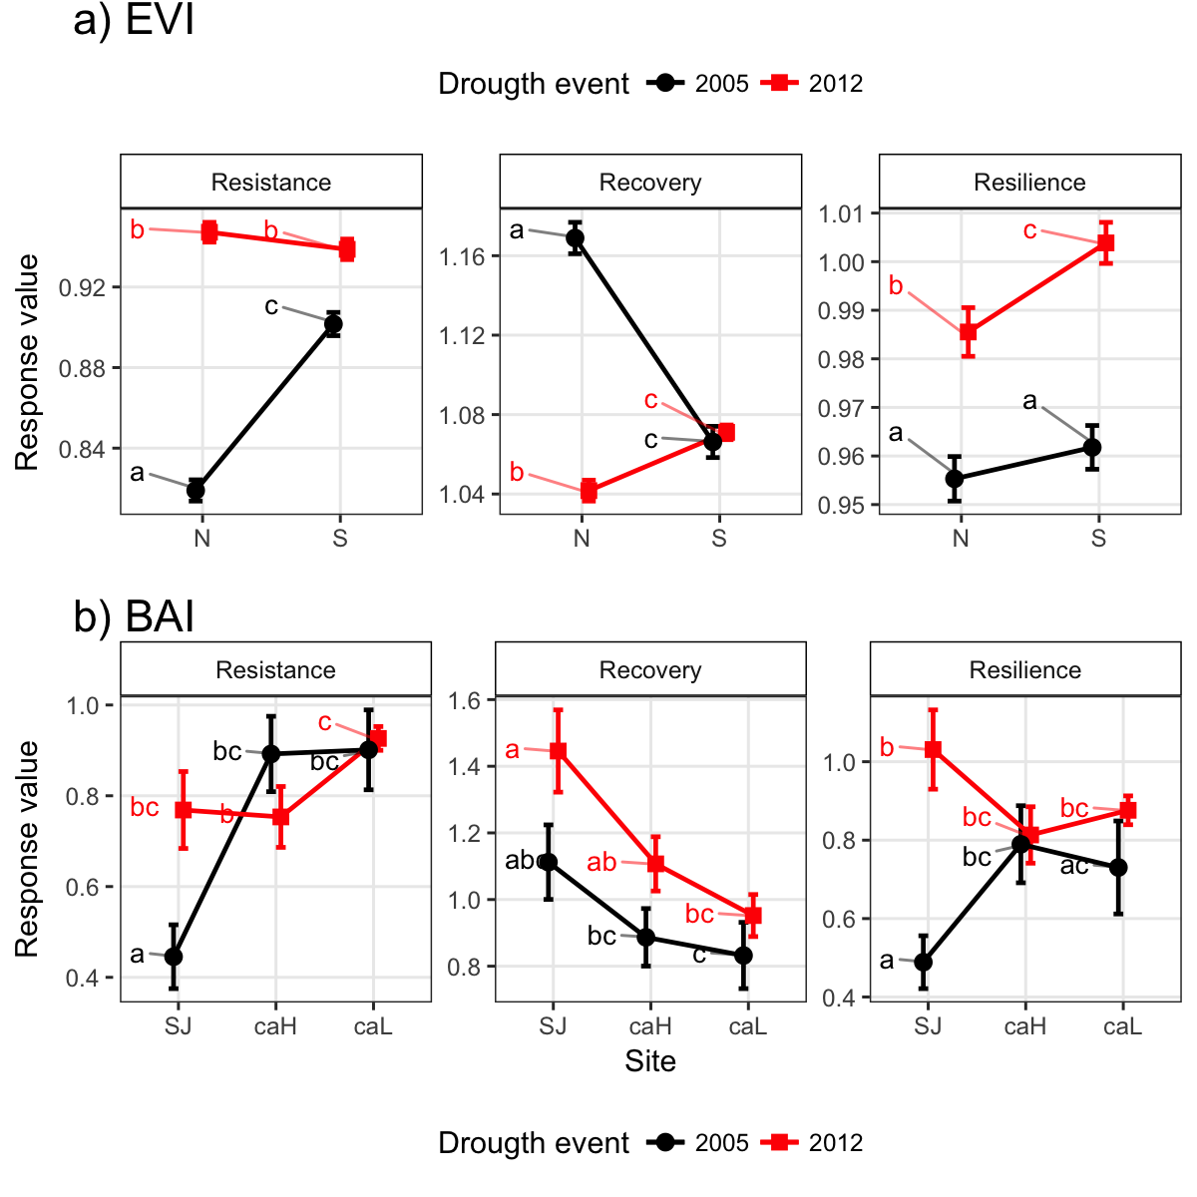

**Figure 4.** Response of *Q. pyrenaica* forests to 2005 (*black*) and 2012 (*red*) drought events in terms of resistance, recovery and resilience of greenness (EVI; a) and tree growth (BAI; b) by site. Different letters above bars indicate significant post hoc differences between groups (see material and methods).

### Figure 5

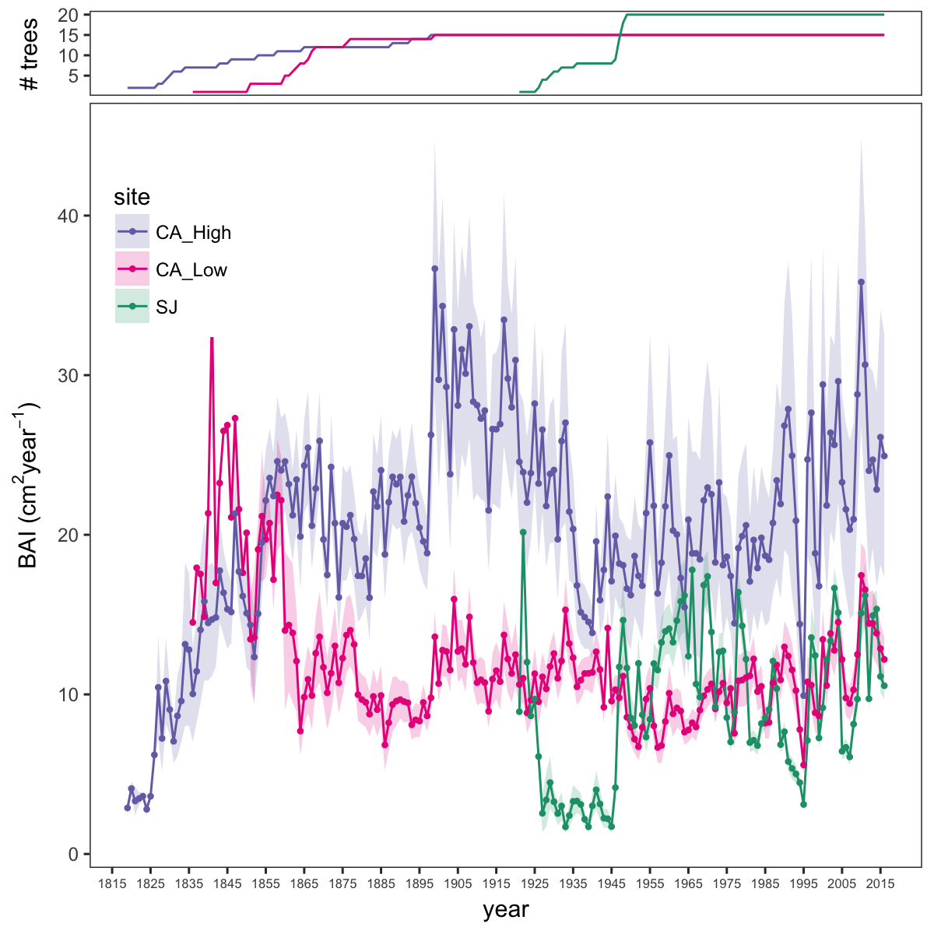

**Figure 5.** Basal Area Increment (BAI) chronologies of *Q. pyrenaica* for northern population (SJ; *green*) and southern ones: low-elevation (CA_Low; *pink*) and high-elevation (CA_High, *purple*) sites. Shading areas coorespond to standard error of the mean. Number of series are displayed in the upper plot.

# Figure 6

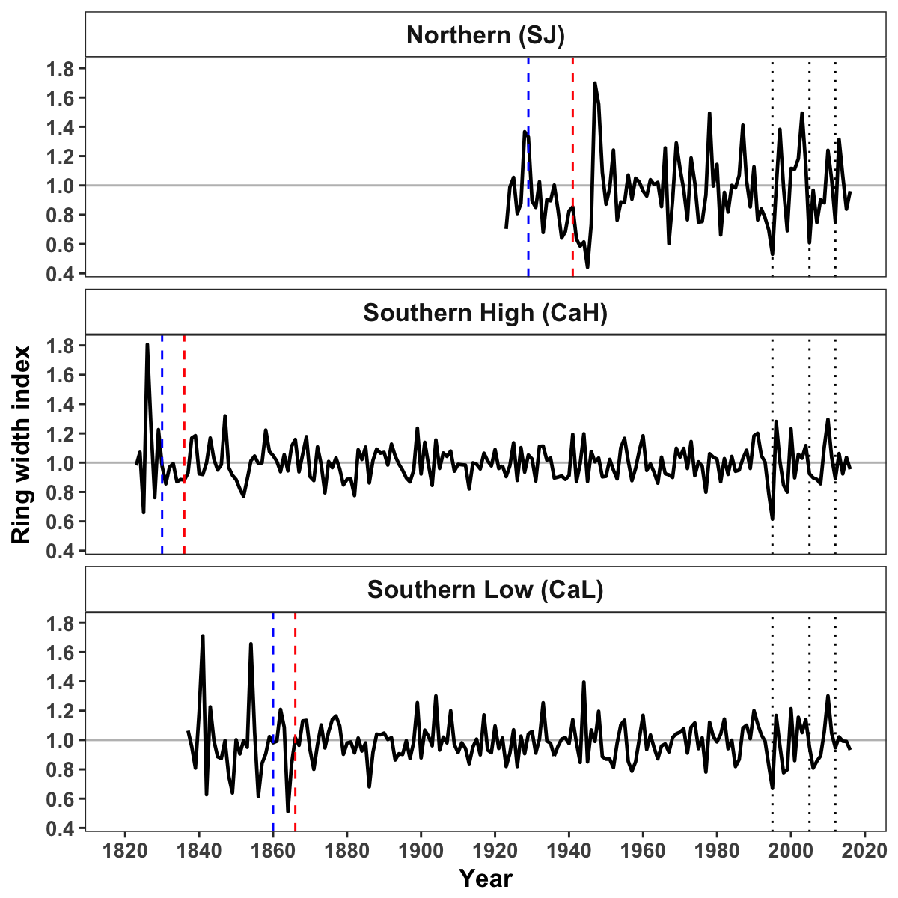

**Figure 6.** Residual Tree-ring chronologies obtained for the *Q. pyrenaica* sites. Dashed red lines indicate the start of the reliable period (EPS > 0.85). Dotted black lines showing the three most recent severe drought years (1995, 2005 and 2012).

# Figure 7

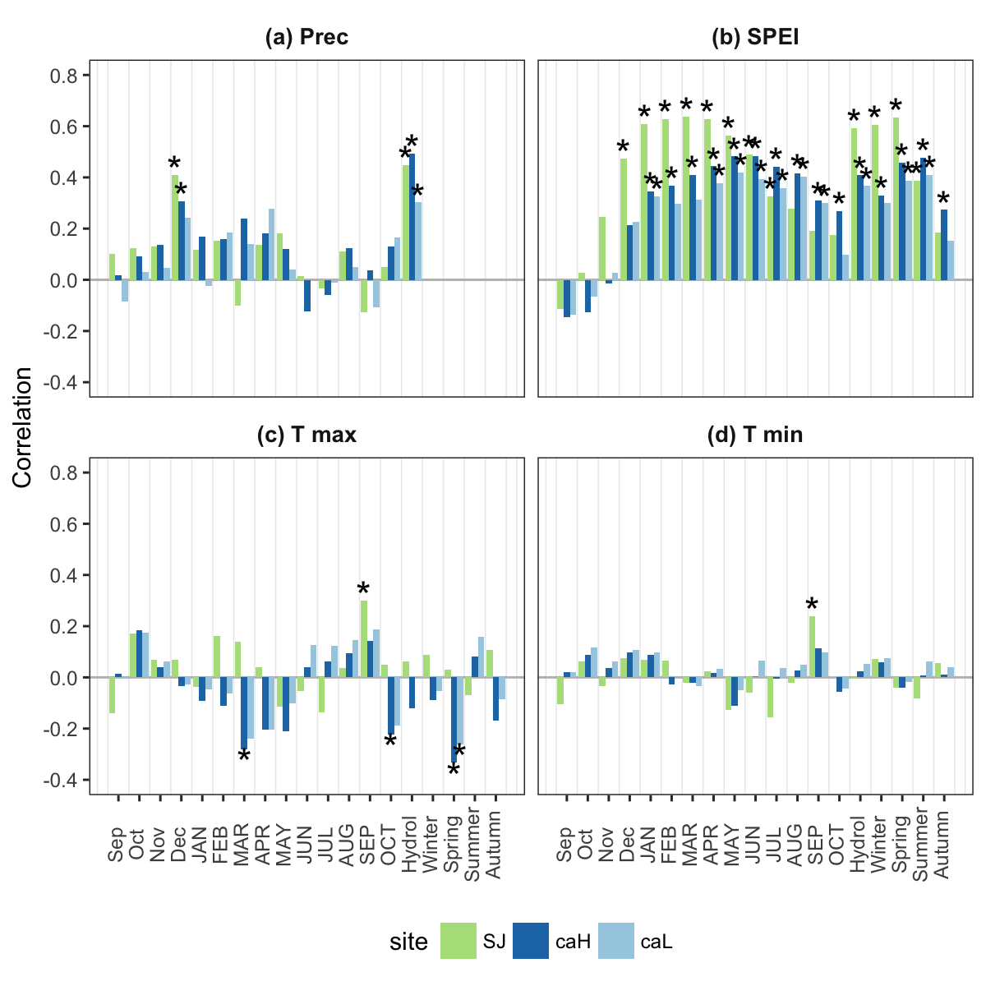

**Figure 7.** Correlation coefficients obtained by relating tree-ring residual chronologies (RWI) of *Q. pyrenaica* and monthly climatic data (precipitation (a), SPEI (b), maximun (c) and minimun (d) temperatures) for northern site (*green* bars), low-elevation southern site (*light blue* bars) and high-elevation shouthern (*dark blue* bars) site. Asteriks indicate significant ($P<0.05$) correlation coefficients.

# Figure 8

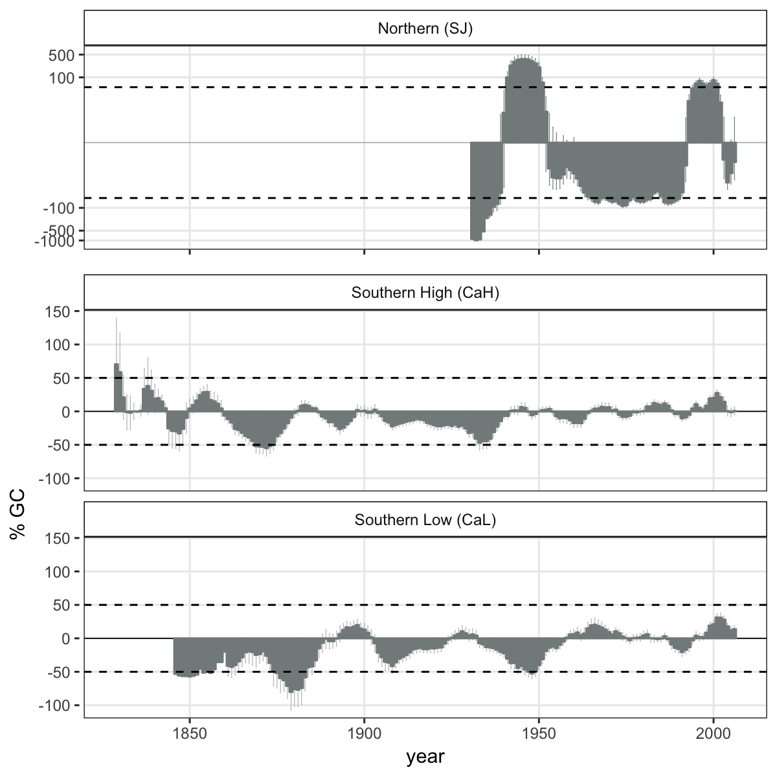

**Figure 8.** Comparison of median growth change ($GC$) following (Nowacki and Abrams 1997) for *Q. pyrenaica* sites. Dashed black lines indicate a threshold of 50 % of GC (see material and methods).

# Figure 9

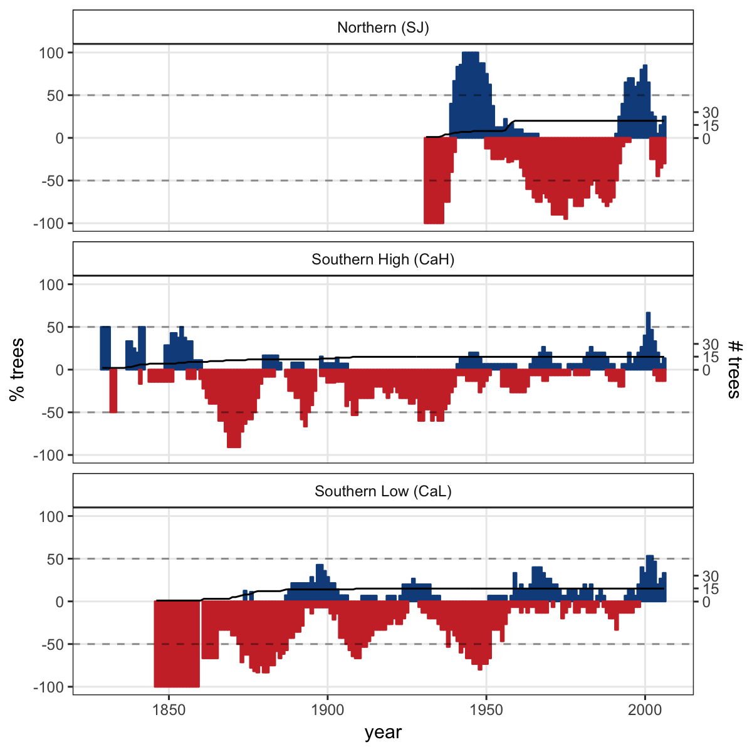

**Figure 9**. Percentage of *Q. pyrenaica* trees affected by GC > 50 % by site. *Black* line shows number of trees (rigth-axis).

# Supplementary

## Figures

**Figure S1** Acumulated monthly precipitation during the hydrological year 2004-2005 (blue line) and 2011-2012 (red line). The boxplot representing the average from 1940-2015 period. Data from meteorological station Granada, Base Aérea (National Spanish Meteorological Services (AEMET)).

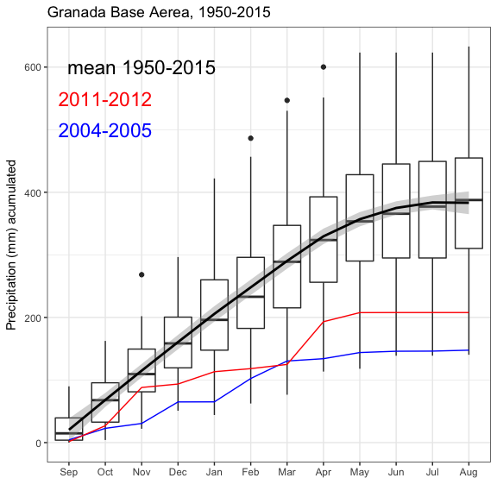

**Figure S2**. Spatial distribution of the EVI-annual trends ($τ$) for the period 2000-2016. Negative values (*red* values) indicate negative trends and positive values (*green* values) indicate positive trends.

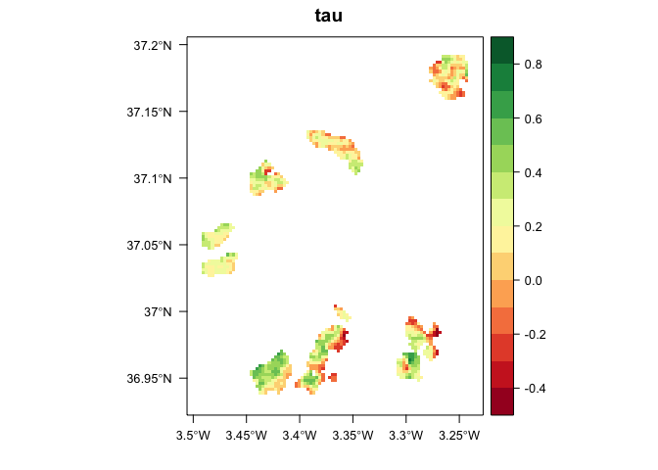

**Figure S3.** Percentage of pixels showing browning, greenning or no-changes during the 2005 and 2012 drought events according to EVI standardized anomalies.

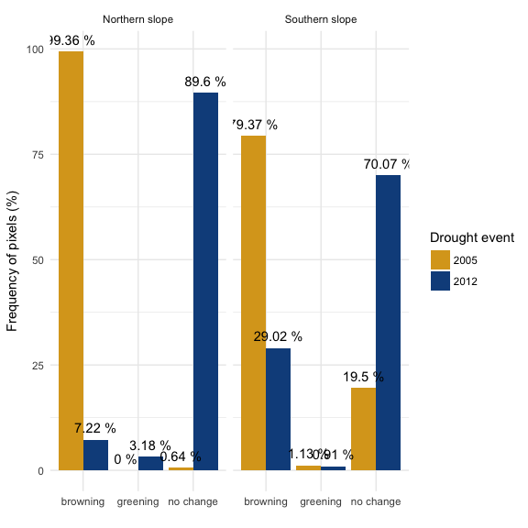

**Figure S4.** Correlation between indices of resilience (Rt, resistance; Rc, recovery; Rs, Resilience) using periods of several lengths (2, 3 and 4 years after a drought). Top plots (a, b and c) showing the resilience indices of greenness (EVI) to drought; and bottom plots (d, e, f) the resilience indices of tree-growth (BAI) to drought. *ws2*, *ws3* and *ws4* indicate periods of 2, 3 and 4 years after a drought.

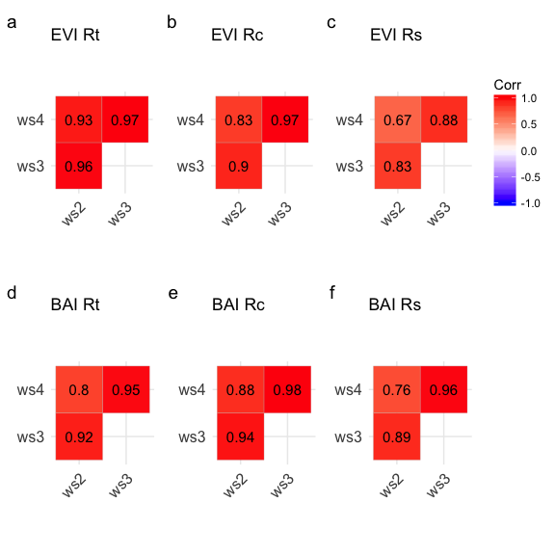

Beguería, S., S. M. Vicente-Serrano, F. Reig, and B. Latorre. 2014. Standardized precipitation evapotranspiration index (spei) revisited: Parameter fitting, evapotranspiration models, tools, datasets and drought monitoring. International Journal of Climatology 34:3001–3023.

Benito, B., J. Lorite, and J. Peñas. 2011. Simulating potential effects of climatic warming on altitudinal patterns of key species in mediterranean-alpine ecosystems. Climatic Change 108:471–483.

Biondi, F., and F. Qeadan. 2008. A theory-driven approach to tree-ring standardization: Defining the biological trend from expected basal area increment. Tree-Ring Research 64:81–96.

Brewer, S., R. Cheddadi, J. de Beaulieu, and M. Reille. 2002. The spread of deciduous quercus throughout europe since the last glacial period. Forest Ecology and Management 156:27–48.

Bunn, A. G. 2008. A dendrochronology program library in r (dplR). Dendrochronologia 26:115–124.

Bunn, A. G. 2010. Statistical and visual crossdating in r using the dplR library. Dendrochronologia 28:251–258.

Cabello, J., D. Alcaraz-Segura, R. Ferrero, A. Castro, and E. Liras. 2012. The role of vegetation and lithology in the spatial and inter-annual response of {evi} to climate in drylands of southeastern spain. Journal of Arid Environments 79:76–83.

Camacho-Olmedo, M., P. García-Martínez, Y. Jiménez-Olivencia, J. Menor-Toribio, and A. Paniza-Cabrera. 2002. Dinámica evolutiva del paisaje vegetal de la alta alpujarra granadina en la segunda mitad del s. xx. Cuadernos Geográficos 32:25–42.

Camarero, J. J., C. Bigler, J. C. Linares, and E. Gil-Pelegrín. 2011. Synergistic effects of past historical logging and drought on the decline of pyrenean silver fir forests. Forest Ecology and Management 262:759–769.

Cavin, L., and A. S. Jump. 2017. Highest drought sensitivity and lowest resistance to growth suppression are found in the range core of the tree fagus sylvatica l. not the equatorial range edge. Global Change Biology 23:362–379.

Cofiño, A., J. Bedia, M. Iturbide, M. Vega, S. Herrera, J. Fernández, M. Frías, R. Manzanas, and J. Gutiérrez. 2018. The ecoms user data gateway: Towards seasonal forecast data provision and research reproducibility in the era of climate services. Climate Services.

Cook, E., and L. Kairukstis. 1990. Methods of dendrochronology: Applications in the environmental sciences. Springer, Doredrecht.

Didan, K. 2015. MOD13Q1 MODIS/Terra Vegetation Indices 16-Day L3 Global 250m SIN Grid V006. NASA EOSDIS Land Processes DAAC.

Dunn, O. 1964. Multiple comparisons using rank sums. Technometrics 6:241–252.

Field, A., J. Miles, and Z. Field. 2012. Discovering statistics using r. Page 1426. SAGE.

Franco, A. 1990. Quercus l. Pages 15–36 *in* A. Castroviejo, M. Laínz, G. López-González, P. Montserrat, F. Muñoz-Garmendia, J. Paiva, and L. Villar, editors. Flora ibérica. Real Jardín Botánico, CSIC, Madrid.

Fraver, S., and A. S. White. 2005. Identifying growth releases in dendrochronological studies of forest disturbance. Canadian Journal of Forest Research 35:1648–1656.

Fritts, H. C. 1976. Tree rings and climate. Academic Press, London.

Frías, M., M. Iturbide, R. Manzanas, J. Bedia, J. Fernández, S. Herrera, A. Cofiño, and J. Gutiérrez. 2018. An r package to visualize and communicate uncertainty in seasonal climate prediction. Environmental Modelling & Software 99:101–110.

Gao, Q., W. Zhu, M. W. Schwartz, H. Ganjurjav, Y. Wan, X. Qin, X. Ma, M. A. Williamson, and Y. Li. 2016. Climatic change controls productivity variation in global grasslands. Scientific Reports:26958.

García, I., and P. Jiménez. 2009. 9230 robledales de quercus pyrenaica y robledales de quercus robur y quercus pyrenaica del noroeste ibérico. Pages 1–66 *in* VV.AA., editor. Bases ecológicas preliminares para la conservación de los tipos de hábitat de interés comunitario en españa. Ministerio de Medio Ambiente, y Medio Rural y Marino, Madrid.

García-Herrera, R., E. Hernández, D. Barriopedro, D. Paredes, R. M. Trigo, I. F. Trigo, and M. A. Mendes. 2007. The Outstanding 2004/05 Drought in the Iberian Peninsula: Associated Atmospheric Circulation. Journal of Hydrometeorology 8:483–498.

Gavilan, R. G., D. S. Mata, B. Vilches, and G. Entrocassi. 2007. Modeling current distribution of spanish quercus pyrenaica forests using climatic parameters. Phytocoenologia 37:561–581.

Gazol, A., J. J. Camarero, W. R. L. Anderegg, and S. M. Vicente-Serrano. 2017. Impacts of droughts on the growth resilience of northern hemisphere forests. Global Ecology and Biogeography 26:166–176.

Gea-Izquierdo, G., and I. Cañellas. 2014. Local climate forces instability in long-term productivity of a mediterranean oak along climatic gradients. Ecosystems 17:228–241.

Gouveia, C. M., P. Ramos, A. Russo, and R. M. Trigo. 2015. Drought trends in the Iberian Peninsula over the last 112 years. Page 12680 *in* EGU general assembly conference abstracts.

Granda, E., A. Q. Alla, N. A. Laskurain, J. Loidi, A. Sánchez-Lorenzo, and J. J. Camarero. 2017. Coexisting oak species, including rear-edge populations, buffer climate stress through xylem adjustments. Tree Physiology.

Hampe, A., and R. J. Petit. 2005. Conserving biodiversity under climate change: The rear edge matters. Ecology Letters 8:461–467.

Haylock, M. R., N. Hofstra, A. M. G. Klein Tank, E. J. Klok, P. D. Jones, and M. New. 2008. A european daily high-resolution gridded data set of surface temperature and precipitation for 1950–2006. Journal of Geophysical Research 113:D20119.

Holmes, R. L. 1983. Computer-assisted quality control in tree-ring dating and measurement. Tree-Ring Bulletin 43:69–78.

Huete, A., K. Didan, T. Miura, E. Rodriguez, X. Gao, and L. Ferreira. 2002. Overview of the radiometric and biophysical performance of the {modis} vegetation indices. Remote Sensing of Environment 83:195–213.

Krapivin, V. F., C. A. Varotsos, and V. Y. Soldatov. 2015. Remote-sensing technologies and data processing algorithms. Pages 119–219 *in* New ecoinformatics tools in environmental science: Applications and decision-making. Springer International Publishing.

Lloret, F., E. G. Keeling, and A. Sala. 2011. Components of tree resilience: Effects of successive low-growth episodes in old ponderosa pine forests. Oikos 120:1909–1920.

Mair, P., F. Schoenbrodt, and R. Wilcox. 2017. WRS2: Wilcox robust estimation and testing.

Mangiafico, S. 2017. Rcompanion: Functions to support extension education program evaluation.

Martínez-Parras, J. M., and J. Molero-Mesa. 1982. Ecología y fitosociología de quercus pyrenaica willd. en la provincia bética. los melojares béticos y sus etapas de sustitución. Lazaroa 4:91–104.

Martínez-Vilalta, J. 2018. The rear window: Structural and functional plasticity in tree responses to climate change inferred from growth rings. Tree Physiology.

Melendo, M., and F. Valle. 2000. Estudio comparativo de los melojares nevadenses. Pages 463–479 *in* J. Chacón and J. Rosúa, editors. I conferencia internacional sierra nevada. Universidad de Granada, Granada.

Nowacki, G. J., and M. D. Abrams. 1997. Radial-growth averaging criteria for reconstructing disturbance histories from presettlement-origing oaks. Ecological Monographs 67:225–249.

Olalde, M., A. Herrán, S. Espinel, and P. G. Goicoechea. 2002. White oaks phylogeography in the iberian peninsula. Forest Ecology and Management 156:89–102.

Pérez-Luque, A. J., R. Zamora, F. J. Bonet, and R. Pérez-Pérez. 2015a. Dataset of migrame project (global change, altitudinal range shift and colonization of degraded habitats in mediterranean mountains). PhytoKeys 56:61–81.

Pérez-Luque, A., R. Pérez-Pérez, F. Bonet-García, and P. Magaña. 2015b. An ontological system based on modis images to assess ecosystem functioning of natura 2000 habitats: A case study for quercus pyrenaica forests. International Journal of Applied Earth Observation and Geoinformation 37:142–151.

Piovesa, G., F. Biondi, A. D. Filippo, A. Alessandrini, and M. Maugeri. 2008. Drought-driven growth reduction in old beech (fagus sylvatica l.) forests of the central apennines, italy. Global Change Biology 14:1265–1281.

Pohlert, T. 2014. The pairwise multiple comparison of mean ranks package (pmcmr).

Pohlert, T. 2017. Trend: Non-parametric trend tests and change-point detection.

R Core Team. 2017. R: A language and environment for statistical computing. R Foundation for Statistical Computing, Vienna, Austria.

Reyes-Díez, A., D. Alcaraz-Segura, and J. Cabello-Piñar. 2015. Implicaciones del filtrado de calidad del índice de vegetación evi para el seguimiento funcional de ecosistemas. Revista de Teledeteccion 2015:11–29.

Rivas-Martínez, S., T. Díaz, F. Fernández-González, J. Izco, J. Loidi, and M. Lousã. 2002. Vascular plant communities of spain and portugal. addenda to the syntaxonomical checklist of 2001. part ii. Itinera Geobotanica 15:5–922.

Río, S. del, L. Herrero, and Á. Penas. 2007. Bioclimatic analysis of the quercus pyrenaica forests in spain. Phytocoenologia 37:541–560.

Rodríguez-Sánchez, F., A. Hampe, P. Jordano, and J. Arroyo. 2010. Past tree range dynamics in the iberian peninsula inferred through phylogeography and palaeodistribution modelling: A review. Review of Palaeobotany and Palynology 162:507–521.

Rubino, D., and B. McCarthy. 2004. Comparative analysis of dendroecological methods used to assess disturbance events. Dendrochronologia 21:97–115.

Samanta, A., S. Ganguly, H. Hashimoto, S. Devadiga, E. Vermote, Y. Knyazikhin, R. R. Nemani, and R. B. Myneni. 2010. Amazon forests did not green-up during the 2005 drought. Geophysical Research Letters 37:L05401.

Samanta, A., S. Ganguly, E. Vermote, R. R. Nemani, and R. B. Myneni. 2012. Interpretation of variations in modis-measured greenness levels of amazon forests during 2000 to 2009. Environmental Research Letters 7:024018.

Sánchez-Salguero, R., J. J. Camarero, M. Dobbertin, Á. Fernández-Cancio, A. Vilà-Cabrera, R. D. Manzanedo, M. A. Zavala, and R. M. Navarro-Cerrillo. 2013. Contrasting vulnerability and resilience to drought-induced decline of densely planted vs. natural rear-edge pinus nigra forests. Forest Ecology and Management 310:956–967.

Sokal, R., and F. Rohlf. 1995. Biometry: The principles and practice of statistics in biological research. Page 887. Freeman, New York.

Taxonomic and functional diversity of a quercus pyrenaica willd. rhizospheric microbiome in the mediterranean mountains. 2017. Forests 8:390.

Trigo, R. M., J. A. Añel, D. Barriopedro, R. García-Herrera, L. Gimeno, R. Castillo, M. R. Allen, and A. Massey. 2013. The record Winter drought of 2011-12 in the Iberian Peninsula [in "Explaining Extreme Events of 2012 from a Climate Perspective. [Peterson, T. C., M. P. Hoerling, P.A. Stott and S. Herring, Eds.] 94:S41–S45.

Valbuena-Carabaña, M., and L. Gil. 2013. Genetic resilience in a historically profited root sprouting oak (quercus pyrenaica willd.) at its southern boundary. Tree Genetics & Genomes 9:1129–1142.

Valbuena-Carabaña, M., and L. Gil. 2017. Centenary coppicing maintains high levels of genetic diversity in a root resprouting oak (quercus pyrenaica willd.). Tree Genetics & Genomes 13:28.

Valbuena-Carabaña, M., U. L. de Heredia, P. Fuentes-Utrilla, I. González-Doncel, and L. Gil. 2010. Historical and recent changes in the spanish forests: A socio-economic process. Review of Palaeobotany and Palynology 162:492–506.

Vicente-Serrano, S. M., S. Beguería, and J. I. López-Moreno. 2010. A multiscalar drought index sensitive to global warming: The standardized precipitation evapotranspiration index. Journal of Climate 23:1696–1718.

Vicente-Serrano, S. M., J. I. López-Moreno, S. Beguería, J. Lorenzo-Lacruz, A. Sanchez-Lorenzo, J. M. García-Ruiz, C. Azorín-Molina, E. Morán-Tejeda, J. Revuelto, R. Trigo, F. Coelho, and F. Espejo. 2014. Evidence of increasing drought severity caused by temperature rise in southern Europe. Environmental Research Letters 9:044001.

Vicente-Serrano, S. M., M. Tomas-Burguera, S. Beguería, F. Reig, B. Latorre, M. Peña-Gallardo, M. Y. Luna, A. Morata, and J. C. González-Hidalgo. 2017. A high resolution dataset of drought indices for spain. Data 2.

Vilches de la Serna, B. 2014. Comprehensive study of “quercus pyrenaica” willd. forests at iberian peninsula: Indicator species, bioclimatic, and syntaxonomical characteristics. PhD thesis, Complutense University of Madrid, Madrid.

Vivero, J., J. Prados, and J. Hernández-Bermejo. 2000. Quercus pyrenaica willd. Pages 303–306 *in* G. Blanca, B. Cabezudo, J. Hernández-Bermejo, C. Herrera, J. Muñoz, and B. Valdés, editors. Libro rojo de la flora silvestre amenzada de andalucía. ii. especies vulnerables. Consejería de Medio Ambiente, Junta de Andalucía, Sevilla.

Wigley, T. M. L., K. R. Briffa, and P. D. Jones. 1984. On the average value of correlated time series, with applications in dendroclimatology and hydrometeorology. Journal of Climate and Applied Meteorology 23:201–213.

Wilcox, R. 2012. Introduction to robust estimation and hypothesis testing (third edition). Page 608. Third Edition. Academic Press.

Zang, C., and F. Biondi. 2015. Treeclim: An r package for the numerical calibration of proxy-climate relationships. Ecography 38:431–436.